Teens in the Driver Seat Social Media Toolkit
AUDIENCE OF ALL AGES
National Teen Driver Safety Week is October 17-23 this year. Be part of the change and join other teens, parents and traffic safety advocates across the country in a national dialogue. Be the best kind of influencer – the kind that could save lives. Get the facts and use them to make sure your friends and family are safe drivers and respectful passengers.
Included in this Kit:
- 5 social media graphics
- 3 social media sample messages
- Facts about teen driver crashes
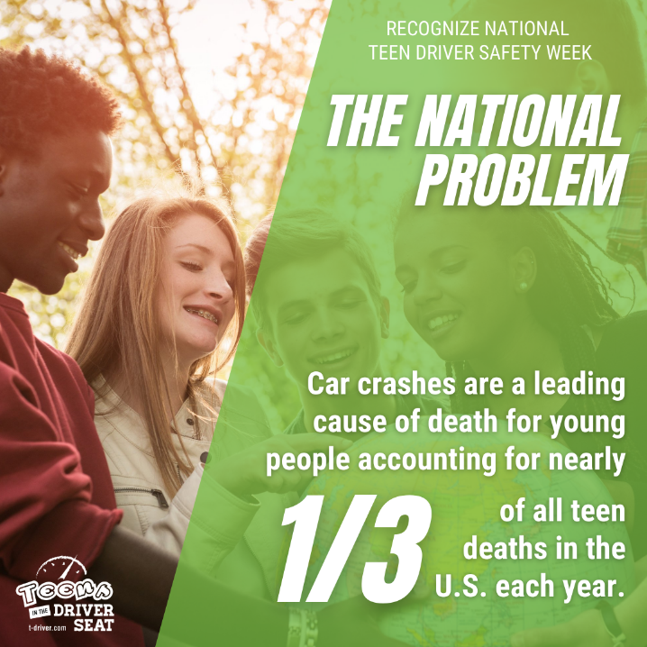 | This week we recognize National Teen Driver Safety Week. Motor vehicle crashes are a leading cause of death for teens (15-18 years old) in the United States, but together we can help end teen car crashes. #NTDSW #teendriver
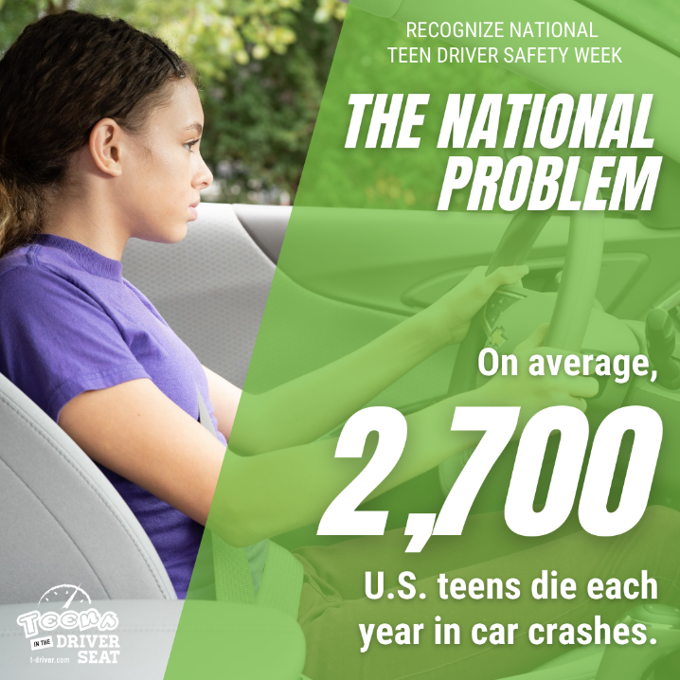
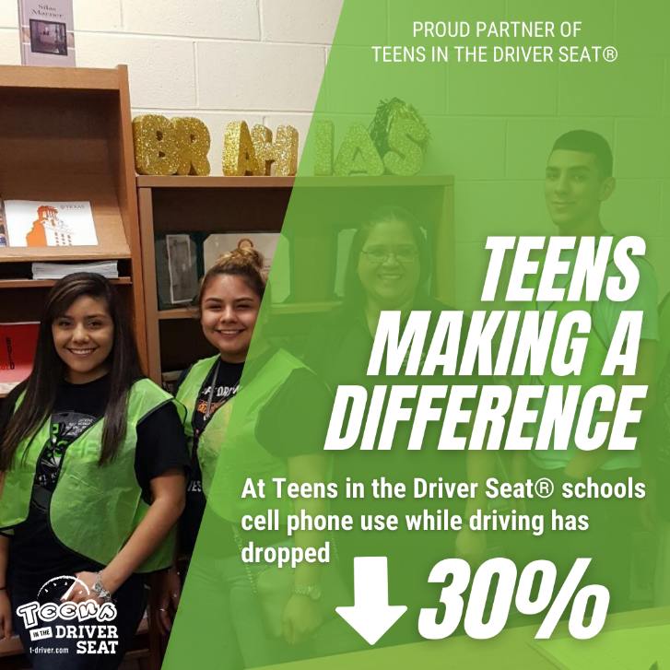 | We are proud to partner with Teens in the Driver Seat as they continue to educate and empower youth to make a difference in their community. Teens are worth fighting for, and if you give them the tools and incentives you may be surprised at how they respect the rules of the road. #teendriver #NTSDW  We are proud to partner with @teensdriverseat as they continue to educate and empower youth to make a difference in their community. Teens are worth fighting for, and if you give them the tools and incentives you may be surprised at how they respect the rules of the road. #teendriver #NTSDW
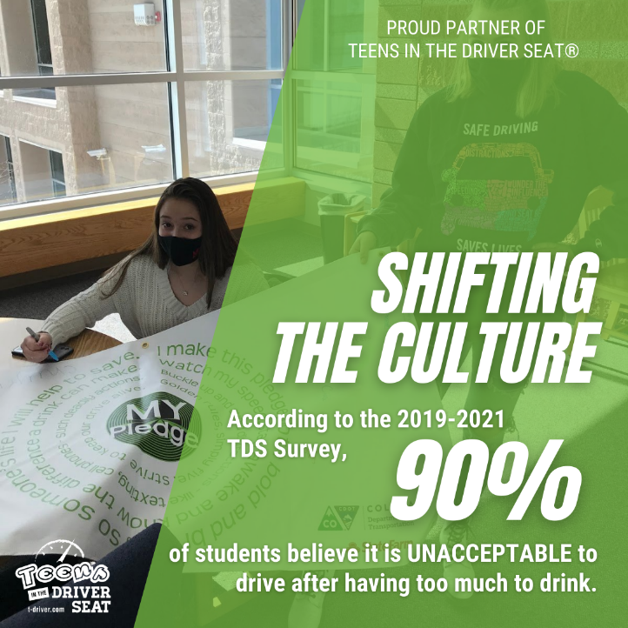
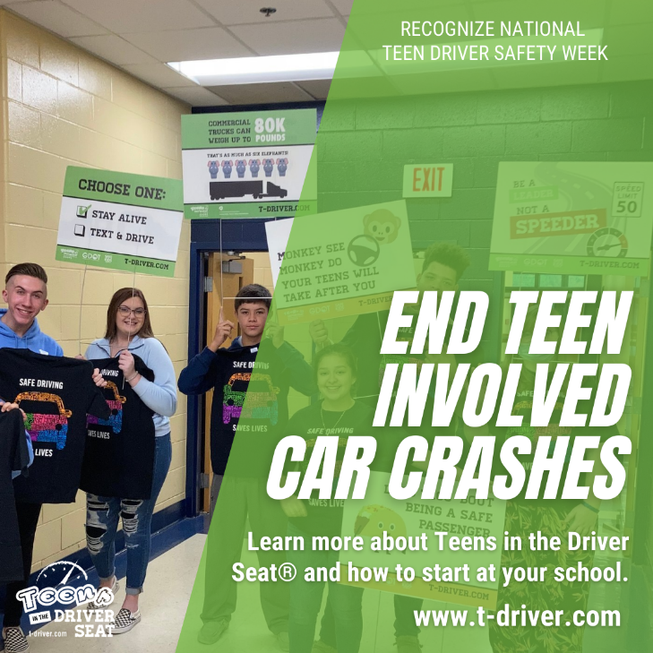 | Want to be part of the movement to end teen car crashes? Join Teens in the Driver Seat, an evidence-based, best practice program on a mission to empower youth to be the change in traffic safety. #teendriver #NTDSW  Want to be part of the movement to end teen car crashes? Join @teendriverseat an evidence-based best practice program on a mission to empower youth to be the change in traffic safety. #teendriver #NTDSW

During National Teen Driver Safety Week, let’s all work together to help the U.S. Department of Transportation’s National Highway Traffic Safety Administration (NHTSA) spread the word about teen driving safety.
Know the Facts About Teen Driver Fatalities (NHTSA)
- Motor vehicle crashes are a leading cause of death for teens (15-18 years old) in the United States.
- In 2019, there were 2,042 people killed in crashes involving a teen passenger vehicle driver (15-18 years old); 628 of the deaths were the teen passenger vehicle driver.
- Others may influence your driving choices, but it’s ultimately up to YOU to make the right decisions. Here are some of teens’ biggest risks when behind the wheel:
  - Impaired Driving: While they’re too young to legally buy, possess, or consume alcohol, 16% of teen passenger vehicle drivers involved in fatal crashes in 2019 had alcohol in their system. Alcohol isn’t the only substance that can impair your driving ability: marijuana affects a driver’s ability to react to their surroundings. Driving is a complex task and marijuana slows the reaction time. Illegal, prescription, or over-the-counter drugs can also impair driving and have deadly consequences.
  - Seat Belts: Seat belts are designed to keep you safe, whether you’re sitting in the front or back seat. They prevent you from being ejected from your vehicle in the event of a crash, but they only work if you use them correctly. In 2019, almost half (45%) of the teen passenger vehicle drivers who died in crashes were unbuckled. Even worse, when the teen driver involved in the fatal crash wasn’t wearing a seatbelt, nine out of 10 of the passengers who died were also unbuckled. Remember to Buckle Up. Every Trip. Every Time.

  - Distracted Driving: Despite popular opinion, no one is good at multitasking. Distractions while driving are more than just risky — they can be deadly. In 2019, among teen passenger vehicle drivers involved in fatal crashes, 10% were reported as distracted at the time of the crash. The use of mobile devices while driving is a big problem but there are other risks, like adjusting the radio, applying makeup, eating, drinking, or distractions from other vehicle passengers.
  - Speeding: In 2019, more than one-quarter (27%) of all teen passenger vehicle drivers involved in fatal crashes were speeding at the time of the crash. Males were more likely to be involved in fatal crashes than females.
  - Passengers: Teen drivers transporting passengers can lead to tragic results. Research shows that the risk of a fatal crash goes up in direct relation to the number of passengers in a motor vehicle. Meaning you’re more likely to act up in front of your friends. In fact, teen drivers engaging in risky behavior triples when traveling with multiple passengers.

